Country Results Report
The Biodiversity Finance Initiative (BIOFIN) Programme in Malaysia
REPORTING PERIOD: January to December 2025

25 December 2025
Draft

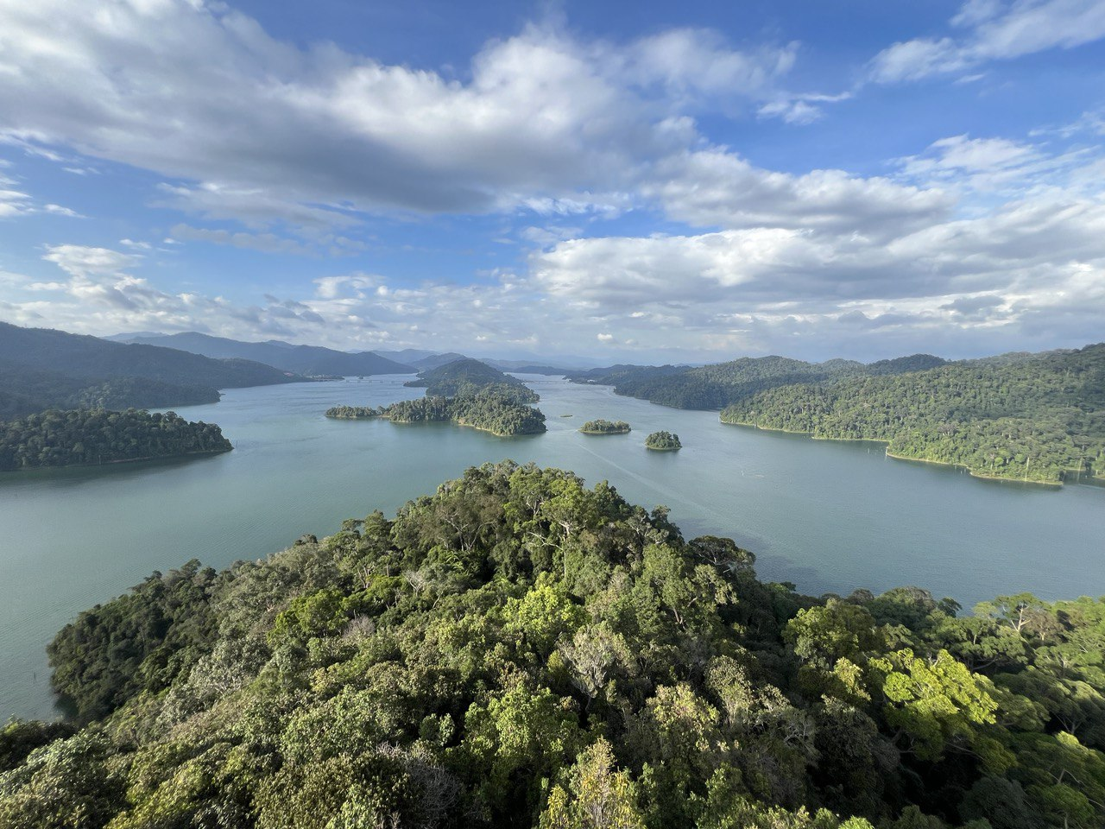

BIOFIN COUNTRY PROGRAMME
W: https://www.biofin.org/index.php/malaysia

BIOFIN COUNTRY PROGRAMME PROFILE

Country: Malaysia
Geographic coverage: Country-wide, with site-specific projects in the following sub-national geographic area: (1) Sabah.
Programme period (as funded by Phase II/Phase II Extended funds): Jul 2023 – Dec 2030
Budget (from Phase II/Phase II Extended funds): USD 540,000 (Germany); USD 577,800 (EU); USD 145,800 (IKI funds)

Photo credits
Cover: View of Belum-Temengor Forest, Peninsular Malaysia (Dr Angkillah Maniam)

Table of Contents
Table of Contents i
Executive summary ii
A. Country factsheet: the country’s biodiversity finance profile and the programming approach 1
A.1. Biodiversity finance profile 1
A.2. National Implementation context 3
B.Overview of Key Results 4
B.1. PIR>BER>FNA>BFP 4
B.2. Implementation of Finance Solutions 4
C.Social inclusion stories 6
D.Lessons learned and adaptive measures 6
E.Risks: programmatic risks and social and environmental risks 7
E.1. Programmatic risks (risks to the programme) 7
E.2. Social and environmental risks (of the programme) 7

List of annexes and related notes 9
Annex 1: Indicator Tracking Table (in Excel) 9

Executive summary
Progress toward targeted results
Validated BFP (following the validation of a PIR, BER, and FNA)
The Biodiversity Finance Plan for Malaysia was validated and made available on BIOFIN webpage in March 2022.
Finance solution 1: Strengthening of the implementation effectiveness of Ecological Fiscal Transfer (EFT) scheme in Malaysia

The introduction of EFT mechanism was in part supported by UNDP-BIOFIN and took several years of preparatory work. EFT was highlighted as one of the priority finance solutions with potential high success for implementation in the country in the Biodiversity Finance Plan (BFP). In the years 2019 to 2026, a combined budget allocation of more than $235.33 million was transferred from the Federal to the States using the EFT mechanism for protecting and expanding forest reserves and protected areas. In the 2026 national budget, $ 58 million (maintained from last year) is allocated for EFT. The implementation of EFT has been successful with 350,000 hectares being gazetted as new protected areas, with 90,000 hectares of newly gazetted terrestrial protected areas and more than 250,000 hectares of marine protected areas.

The BIOFIN Phase 2 will enhance the implementation effectiveness of the current EFT scheme and establish possible policy, legal and institutional pathways for EFT institutionalization in Malaysia. In this phase, the project will develop the business case of a ‘blended finance’ approach to mobilize additional funds from the state government and strategic partners in addition to the EFT allocation for biodiversity and forest conservation projects.
In the first half of 2025, BIOFIN Malaysia intensified its efforts to institutionalize the Ecological Fiscal Transfer (EFT) as a long-term biodiversity finance mechanism at the national level. The work built on the momentum created by the November 2024 National EFT Sensemaking Workshop and focused on translating stakeholder inputs into a validated action roadmap and operational guidance. A key milestone was the EFT Validation Workshop held on 19–20 May 2025, co-convened by UNDP-BIOFIN and the Ministry of Natural Resources and Environmental Sustainability (NRES). The workshop brought together over 30 EFT Managers, including officials from the Ministry of Finance (MOF), Ministry of Economy, State Treasury Departments, State Economic Planning Units (EPUs), and other stakeholders. It served to validate the findings of BIOFIN’s EFT strengthening sensemaking work and to advancing the implementation of the EFT mechanism in Malaysia.

In 2025, Malaysia’s EFT mechanism continued to deliver measurable conservation and fiscal outcomes. Under Budget 2026, NRES successfully secured RM250 million (approximately USD 59 million) for the EFT allocation - marking the commitment from the government on nature conservation. This allocation is expected to sustain state-level conservation actions and enhance the long-term fiscal space for managing protected areas, wildlife corridors, and ecosystem restoration. BIOFIN provided technical and analytical support in formulating the policy justification and monitoring framework that informed the budget proposal, ensuring data-driven rationale and alignment with the 13th Malaysia Plan and the National Policy on Biological Diversity (NPBD) 2022–2030.
The on-going activities towards strengthening the effectiveness and sustainability of EFT are to (i) review and refine the existing operational framework/mechanism for EFT and (ii) conduct feasibility assessments and sensitization/engagement sessions with 2 piloting states. The first pilot will focus on aligning annual EFT planning with results-based budgeting, reviewing fund flow mechanisms between federal and state entities, and improving coordination among relevant agencies. A second pilot will involve development of conservation projects eligible for EFT funding and is attractive for public-private financing to increase buy-in, alongside targeted capacity-building activities to equip local agencies with the tools and understanding to implement the revised NRES EFT Guidelines. BIOFIN will also conduct policy, legal and institutional reviews to identify the possible pathways for establishing a legally entrenched EFT scheme in the long term.
Finance solution 2: Imposition of the Ecosystem Conservation Fee in the State of Sabah, Malaysia
This Finance Solution (FS) aims to create an enabling legal environment to impose the PES-like Ecosystem Conservation Programme (ECP) as a sustainable mechanism for the conservation, management, protection and rehabilitation of the ecosystems, the environment, and natural resources in Sabah. The expected outcome for this FS by end of 2025 is the finance for conservation diversified in Sabah through revenue generated from imposition of Ecosystem Conservation Fee (ECF).
Supported by UNDP-GEF Biodiversity Conservation in Multiple-Use Forest Landscapes (MFL) in Sabah, a draft enactment to impose the Ecosystem Conservation Fee (ECF) was submitted to the Sabah Government in January 2020. Although innovative sustainable financing remains of interest to the state, there is no government agency taking the initiative to expedite the imposition of the ECF at present, and the draft enactment remains at the State Attorney-General’s Chambers.
In June 2024, BIOFIN Team had a high-level dialogue with the Sabah Government to regain the momentum for the imposition of ECF. As an outcome of the dialogue, the draft ECF Enactment was reviewed and deliberated by key Sabah State Agencies. The ECF Cabinet Paper and Enactment draft was tabulated in the State Cabinet for approval on 22nd October, however, the Cabinet decided to keep the proposal under Keep In View (KIV) for further review.
On 18 June 2025 UNDP Malaysia and the Sabah Forestry Department (SFD) co-hosted a workshop in Kota Kinabalu “to reignite momentum for the Ecosystem Conservation Fee”. At the workshop, senior officials from state agencies and local councils renewed commitment to the ECF Initiative, and agreed on concrete next steps: setting up an inter-agency Technical Working Group and holding the next discussion to defining agency roles in collecting and allocating the fee, and revisiting legislative requirements. The stakeholders unanimously agreed to strengthen the business case and cabinet paper for the imposition an ecosystem conservation fee. An immediate next step is to establish an Inter-Ministerial ECF Task Force as a continuation of the workshop working groups, this committee chaired by SFD, would convene and work closely to steer the ECF implementation.
Technical discussions are ongoing at the time of reporting between the Ministry of Finance Sabah, the Attorney General’s Chambers, SFD and related partners to formalize the legal instrument that will institutionalize the ECF under state legislation. Once implemented, the ECF is projected to generate between RM10–15 million annually, earmarked for the protection and restoration of critical habitats such as the Lower Kinabatangan Wildlife Sanctuary and other key forest reserves.
Finance solution 3: Enabling and Scaling up Nature-related Financial Disclosures
[Funded under IKI-TNFD Project]
The inclusion of TNFD in Malaysia's BIOFIN work plan represents a significant milestone. The TNFD framework enables private sectors and financial institutions to evaluate nature-related risks and opportunities, promoting transparency and accountability. Malaysia’s rapid economic development can be attributed to the utilization of the country’s rich natural resources and development of human capital, but it comes at a cost. A study by Malaysia Central Bank - Bank Negara Malaysia (BNM) and World Bank explored nature-related financial risks in Malaysia. The study estimated about 90% (RM733 billion or US$158 billion) of total commercial financing in the country is indirectly dependent on ecosystem services, resulting in potential physical risks with the deterioration of ecosystem services. The economic value of the Peninsular Malaysia’s terrestrial Protected Area network is estimated to deliver an annual net benefit of RM6.5 billion (US$1.4 billion), providing a strong economic case for ensuring or enhancing the delivery of a broad range of ecosystem services even on a conservative estimate.
In COP 28, BNM announced initiatives to develop a risk assessment guide for Malaysian financial institutions and businesses, with the World Bank (WB) and in consultation with Taskforce on Nature-related Financial Disclosures (TNFD). In late 2024, UNDP-BIOFIN Malaysia was approached by BNM to provide additional support to develop the guideline. The guide will be developed based on case studies on the application of the TNFD Locate, Evaluate, Assess and Prepare (LEAP) approach on significant value chain(s) for Malaysia. In this initiative, with the partners, BIOFIN Malaysia is piloting the case study with companies with extensive supply chain in the palm oil and construction industries that present significant pressures to nature. The case study will serve as practical guidance and surface insights on implementation challenges and considerations alongside providing appropriate policy suggestions to enable the efforts of mainstreaming of TNFD implementation in Malaysia. The initiative aims to eventually assist financial institutions (and their clients) in integrating nature-related considerations into their credit and underwriting decisions and ultimately the mainstreaming of nature risk disclosure practices. This will also provide a demonstration effect to other developing countries facing similar challenges.
In the first half of 2025, BIOFIN Malaysia advanced the country’s readiness for nature-related financial disclosure in alignment with the global Taskforce on Nature-related Financial Disclosures (TNFD) framework. Key initiatives included joint participation with Bank Negara Malaysia (BNM) in the regional TNFD Train-the-Trainer (TtT) Workshop in Singapore, strengthening national capacity to apply the LEAP approach. BIOFIN also initiated collaboration with Securities Commission and Bursa Malaysia on a TNFD Corporate Readiness Study, aimed at assessing disclosure maturity among public-listed companies. Collaboration with BNM was further deepened through joint representation at the BIOFIN Global Conference in Chile, where discussions focused on integrating nature-related risks into financial supervision.
The partnership with BNM has made significant progress on multiple fronts. BIOFIN is developing a a national readiness and nature related risk assessment guide for Malaysian financial institutions and businesses, in cooperation with WB and BNM. The LEAP assessment for the 2 pilot corporates and 4 FIs will be included in the report as case studies are completed.
Other Results and Looking Ahead
With the Government of Malaysia recent revision on the National Policy on Biological Diversity (NPBD) 2022-2030, the BIOFIN-supported actions, other than the two Finance Solutions on EFT and ECF, includes the review and update of the BIOFIN Phase I data specifically the BFP and the inventory of subsidies that are harmful to biodiversity. BIOFIN Malaysia is working closely with NRES, Ministry of Economy and MOF to create synergy and cross-project collaboration for achieving the intended results for BIOFIN Phase II Extended, as well as for the NPBD in managing and conserving Malaysia’s biodiversity.
Efforts to institutionalize BIOFIN within government decision-making have also advanced. The national BIOFIN has prepared and submitted a policy brief to the Ministry of Natural Resources and Environmental Sustainability (NRES). This brief advocates formally including EFT as a key biodiversity finance tool in Malaysia’s upcoming 13th Malaysia Plan (2026–2030). This step is aligned with calls for stronger EFT policy in the next five-year plan, and aims to institutionalize funding flows that reward state-level conservation of protected and critical ecosystems. Another milestone to institutionalize implementation of the Biodiversity Finance Plan of Malaysia is the governance set-up of the Finance Working Group to support the National Biodiversity Council. Following discussions at the recent Global Biodiversity Finance Conference, the Deputy Secretary General of NRES proposed a formal link between BIOFIN governance and the national biodiversity framework. In response, the BIOFIN national team has submitted a formal proposal to establish the BIOFIN Project Board as an official subcommittee for biodiversity financing under Malaysia’s National Biodiversity Council.

Country factsheet: the country’s biodiversity finance profile and the programming approach

Biodiversity finance profile

A.1.1 Country’s biological diversity and biodiversity loss drivers
Malaysia is one of the 17 megadiverse countries globally, richly endowed with biological diversity in its forests and marine ecosystems. The combined total of biodiversity in the megadiverse countries makes up almost 70% of all known species in the world.
Increasing population is an important threat to forest resources, with growing demand for food, water, houses, jobs, energy, transportation, and other infrastructure. Drivers of forest degradation, hence the biodiversity loss, were identified as: (a) forest fragmentation; (b) encroachment from past activities like agriculture and settlements; and (c) legacy issues from past management and shifting cultivation. Hunting and poaching continue to present a substantive threat to large forest fauna. In the marine environment, coastal fishery resources are threatened by overfishing. The decline in fish stock is driven by the growing demand for seafood and threats associated with Illegal, Unreported and Unregulated (IUU) fishing. The effects of climate change are expected to have widespread impacts, e.g., an increase in precipitation or extended dry periods can destroy habitats and prompt oil palm farmers to grab additional land to compensate for productivity deterioration. Other pressures that threaten Malaysia’s biodiversity include invasive alien species (IAS) and environmental pollution.

A.1.2 Country’s commitment and engagement on protecting its biological diversity and preventing further loss
Malaysia has always been committed to conserving and managing its biodiversity in a sustainable manner. Malaysia’s pledge, made at the 1992 United Nations Conference on Environment and Development in Rio de Janeiro, to maintain at least 50% of its land area under forest and tree cover in perpetuity, in addition to signing the three Rio Conventions and the Paris Agreement. To date, Malaysia’s forest cover stands at 54.6% or 18.04 million hectares of its total land area, exceeding the country's initial commitment made earlier.
Malaysia ratified the United Nations Convention on Biological Diversity (CBD) in 1994. Malaysia formulated and endorsed the National Policy on Biological Diversity (NPBD) 2016-2025 in February 2016, building on its predecessor policy on 1998 to protect its biodiversity and achieve the CBD goals. The policy functions as Malaysia’s National Biodiversity Strategies and Action Plan (NBSAP). In 2023, the NPBD 2016-2025 was revised and launched as NPBD 2022-2030 with the integration of the Kunming-Montreal Global Biodiversity Framework, adopted on 19 December 2022 during the 15th Meeting of the Conference of the Parties to the UN Convention on Biological Diversity (CBD COP15) in Montreal, Canada.
The Twelfth Malaysia Plan 2021-2025 (12MP) sets out the country’s vision for advancing sustainability and resilience though embracing circular economy and green growth. Managing natural resources efficiently to safeguard natural capital is one of its key priorities, particularly focusing on conserving ecosystems, protecting species and genetic resources, ensuring sustainable utilization and benefits sharing of resources, as well as enhancing conservation of water resources. It underlines the need to utilise natural resources sustainability throughout the value chain to optimise their values, as well as diversifying conservation funding. Strengthening the enabling environment for effective governance is another key priority with the focus on strengthening environmental governance, scaling-up green financing and investments, as well as instilling a sense of ownership and shared responsibility. The national development priorities of the 12MP will continue to be aligned to the Sustainable Development Goals (SDGs) of the 2030 Agenda.

A.1.3 Country’s financial profile
Malaysia is an upper middle-income country (UMIC) with GNI per capita for 2023 was US$11,970, close to the US$13,846 threshold for high-income status. Malaysia’s rapid economic development can be attributed to the utilisation of the country’s rich natural resources and development of human capital, but it comes at a cost. The landmark Bank Negara and World Bank study that explored nature-related financial risks in Malaysia estimated about 90% (RM733 billion or US$158 billion) of total commercial financing in the country is indirectly dependent on ecosystem services, resulting in potential physical risks with the deterioration of ecosystem services. The economic value of the Peninsular Malaysia’s terrestrial Protected Area network is estimated to deliver an annual net benefit of RM6.5 billion (US$1.4 billion), providing a strong economic case for ensuring or enhancing the delivery of a broad range of ecosystem services even on a conservative estimate. Biodiversity finance in Malaysia is primarily sourced from public sector through the development budget allocations under the 5-year Malaysia Plan cycle led by the Ministry of Economy and operating budget allocation under the annual budgetary planning cycle led by the Ministry of Finance Malaysia. Through BIOFIN Phase I in Malaysia, the Biodiversity Expenditure Review exercise determined the projected budget of RM5,747.32 million (US$1,237.8 million) for 2018-2025 or an annual average of RM718 million (US$154.6 million). Using the BIOFIN methodology, the 19 participating organisations estimated that yearly they need three times more, i.e. from RM718 million (US$154.6 million) (projected expenditure) to RM2,162 million (US$465.6 million) (financial needs) thus showing a gap of RM1,447 million (US$311.6 million).

National implementation context
In Malaysia, financing for nature conservation is primarily sourced from public sector (both federal and state governments) but it is generally underfunded. In 2019, the Federal Government launched direct cash transfer scheme under Ecological Fiscal Transfer (EFT) as an added incentive to the State Governments to reinforce nature and biodiversity conservation actions. Though this is a positive and encouraging development, there is a need to assess whether this EFT mechanism is implemented effectively and institutionalized in the long term with sustainable financing from public sources. Beside public finances including EFT, the State Governments also are encouraged to explore other financing instruments to spur investment for protection of nature.
BIOFIN Phase I conducted in Malaysia from February 2017 until August 2019, resulted in the preparation of Biodiversity Expenditure Review (BER), Financial Needs Assessment (FNA) and Biodiversity Finance Plan (BFP). In addition, an Integrated BIOFIN Report and a Policy Brief were prepared for the consideration of government, underlining the need for instituting a structured process for budget planning and increasing investment for achieving national biodiversity and nature conservation objectives. The BFP prioritised the following finance solutions:
- Scale-up Malaysia’s Biodiversity Enforcement Operations Network
- Innovation Challenge Funds for Biodiversity
- Coordination of NCTF and Other Trust Funds in Biodiversity
- Voluntary Sustainable Finance Standards for Finance Sector
- Biodiversity Criteria in Government Green Procurement
- Tax Incentives for Landscaping
- Access and Benefit Funds Sharing for Biodiversity
- Ecological Fiscal Transfers (EFT)
- Building Business Market for Biodiversity
BIOFIN Phase II Extended provides the opportunity to continue the work on EFT and extend support to the State Government of Sabah on Ecosystem Conservation Fee (ECF). It also paves the way for introducing and institutionalizing the BIOFIN methodology to the State agencies, by replicating the lessons and knowledge gained from BIOFIN Phase 1 which was mainly involving agencies from Federal.
The overall desired outcome of the BIOFIN Phase II Extended in Malaysia is financial resources from both government and non-government sources for the conservation and sustainable use of biodiversity are diversified and effectively utilized in support of the achievement of the Kunming-Montreal Global Biodiversity Framework (GBF) aligned National Policy on Biological Diversity 2022 - 2030 in Malaysia. There are two biodiversity finance solutions being prioritized and to be implemented in Malaysia namely:
- Strengthening of the Implementation Effectiveness of Ecological Fiscal Transfer (EFT) scheme in Malaysia.
- Imposition of the Ecosystem Conservation Fee in the State of Sabah in Malaysia
The Malaysia BIOFIN Phase II Extended is under direct implementation by UNDP in Malaysia country office in close collaboration with the Ministry of Natural Resources and Environmental Sustainability (NRES) and Ministry of Finance (MoF) at the federal level. BIOFIN Phase II Extended works with the Natural Resources Office in the Sabah State Government, and other relevant subnational ministries and agencies.
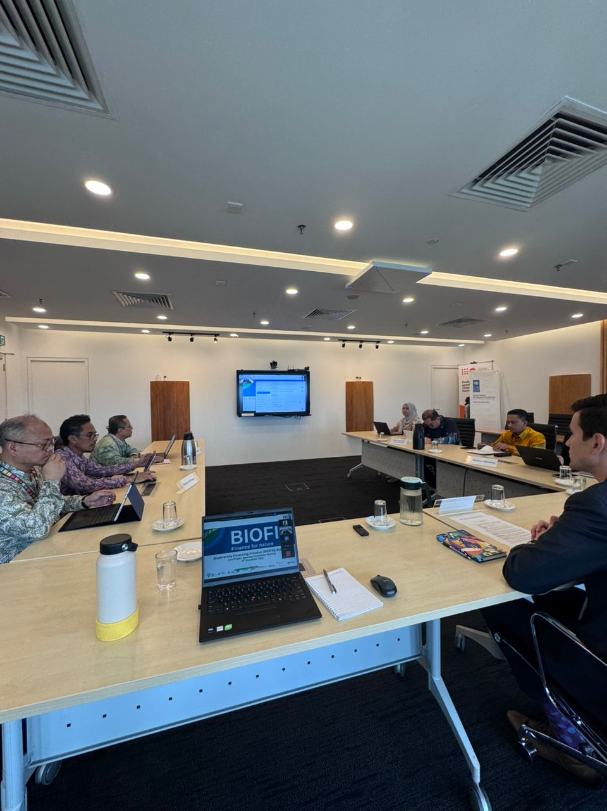
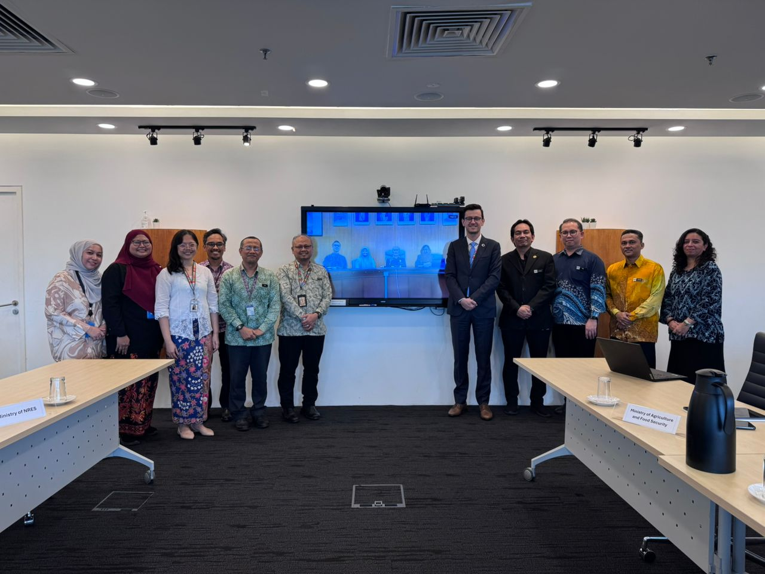
The 2nd Project Steering Committee (PSC) Meeting for BIOFIN Malaysia was convened on 4 December 2025
The 2nd Project Steering Committee (PSC) Meeting for BIOFIN Malaysia marks a significant step in re-establishing high-level governance oversight following a transition period across implementing agencies. The meeting brought together representatives from NRES, MOF, ME, MAFS, Sabah Forestry Department, and financial-sector regulators, reflecting strong inter-ministerial and federal–state engagement. Members reaffirmed BIOFIN’s strategic relevance and the importance of enhancing coordination on biodiversity finance solutions at both federal and subnational levels.
The PSC acknowledged the substantial progress made during the year, including updates to the Biodiversity Expenditure Review (BER), financing needs assessment, and BIOFIN methodology studies. NRES noted that the BER will support Malaysia’s 7th National Report to the CBD and can strengthen resource mobilisation narratives for national planning and budget proposals. MOF and NRES emphasised the need to demonstrate on-the-ground impacts of the Ecological Fiscal Transfer (EFT), including transparency on utilisation of state-level allocations and identification of impactful projects. Both ministries welcomed the proposal to develop a business case for blended financing using EFT as a catalytic instrument.
Discussions also advanced state-level finance solutions. The Sabah Forestry Department shared legal considerations related to the Ecosystem Conservation Fee (ECF), noting that tourism fee collection falls under federal jurisdiction, and confirmed that a feasible implementation pathway is being refined through ongoing technical working groups. The Ministry of Economy expressed interest in aligning BIOFIN work with its national Blue Economy agenda, particularly in lower-income coastal states such as Terengganu, Pahang, and Sabah. The Ministry of Agriculture signalled strong interest in BIOFIN’s work on harmful subsidies and proposed deeper collaboration on models for nature-positive transition, including involving the Ministry of Plantation and Commodities and MITI in a future technical committee.
PSC members agreed to retain the existing permanent membership and recommended that the BIOFIN Secretariat circulate proposed new members for approval through a resolution process. The PSC further supported the establishment of a Technical Committee to enable more frequent, focused inter-agency dialogues on key thematic areas including EFT, ECF, TNFD, PES, Blue Economy, and subsidy reform. The meeting concluded on a positive and collaborative note, with strong endorsement of BIOFIN’s technical contributions and consensus on the need for more regular cross-ministerial engagement to accelerate Malaysia’s biodiversity finance agenda.

Overview of key results

PIR>BER>FNA>BFP
This sub-section is not relevant for the BIOFIN Phase II Extended in Malaysia.

Implementation of Finance Solutions
Malaysia BIOFIN project was initiated in 2018 with Phase I funding. The country rejoined in the Phase II Extended implementation stage with two finance solutions to be implemented from July 2023 until December 2025.

Strengthening of the Implementation Effectiveness of Ecological Fiscal Transfer (EFT) scheme in Malaysia
This Finance Solution (FS) aims to enhance the implementation effectiveness of current EFT scheme and establish possible policy, legal and institutional pathways for EFT institutionalization in Malaysia. There are three main strategies to achieve the objective of this FS. First, a review of the effectiveness of current implementation framework would ascertain that appropriate biological and ecological criteria are applied for the fiscal transfer, and operational mechanism is further improved to encourage the recipient states on earmarking EFT allocation for biodiversity conservation. Second, a policy, legal and institutional review to identify the possible pathways to institutionalize EFT to ensure sustainability of this scheme in the long term as EFT is currently a discretionary incentive subject to political and financial conditions. Third, building the government capacity, specifically the decision makers at the federal level on the importance of effectively and sustainably managed EFT scheme with adequate annual allocation for the protection of nature, as well as the recipient state governments on the specific purpose of EFT and earmarking the utilization of EFT for biodiversity conservation. The key stakeholders for this FS are the Ministry of Finance (MoF) and Ministry of Natural Resources and Environmental Sustainability (NRES) (formerly known as Ministry of Natural Resources, Environment and Climate Change, NRECC). Other stakeholders are the Ministry of Economy, state governments, and federal and state implementing agencies.
The Malaysia country document package for implementation under the BIOFIN Phase II Extended was approved on 12 June 2023. An inception workshop convened on 11 July 2023 involving relevant ministries and agencies from federal and state governments and NGOs discussed on the status and gaps in the EFT implementation, BIOFIN-supported activities, indicators and targets, as well as proposed pilot States for intervention.
The BIOFIN Phase II Extended-funded key activities planned for 2024-2025 are: (i) Review and refine the existing operational framework/mechanism for EFT; (ii) Develop business case for increase in quantum of annual allocation; (iii) Conduct feasibility assessments and sensitization/engagement sessions with the states to increase buy-in; (iv) Pilot EFT utilization for biodiversity conservation actions in at least two states; and (v) Conduct policy, legal and institutional review to identify the possible pathways for establishing a legally entrenched EFT scheme in the long term.
During the reporting period, it is noteworthy that the Prime Minister when tabling the Malaysia Madani Budget 2026 announced that the allocation for the EFT is maintained at RM250 million (the same amount USD58 million) compared to RM200 million (USD43.07 million) in 2024, RM150 million (USD34 million) in 2023, to support the efforts of state governments in increasing the percentage of protected areas and conserving endangered wildlife. As a baseline, EFT was first introduced in 2019 with an initial allocation of RM60 million (USD13.5 million), marking a significant scale-up in federal commitment over the past six years.
In March 2025, the National Finance Council (NFC) approved major updates to the EFT framework, including an increase in the annual allocation from RM200 million to RM250 million and a revision of the distribution formula to better incentivize conservation outcomes. The share of EFT funds linked to ecological criteria was raised from 30% to 50%, and eligibility was expanded to include Other Effective area-based Conservation Measures (OECMs), aligning with national and global biodiversity targets. These changes were informed by stakeholder inputs from the BIOFIN-led EFT Sensemaking Workshop held in November 2024. However, the NFC also introduced a provision to allocate 20% of EFT funds as unearmarked general-purpose transfers—offering greater flexibility to states, but potentially reducing the mechanism’s effectiveness in incentivising biodiversity outcomes if not accompanied by clear safeguards and performance accountability.
To further embed EFT in long-term development planning, UNDP-BIOFIN prepared and submitted a policy paper to the NRES advocating for EFT to be formally recognised as a core biodiversity finance mechanism under the 13th Malaysia Plan (2026–2030). The policy note provided strategic recommendations for institutionalising EFT within the national budgetary framework and served as a technical input for NRES’s ongoing dialogue with the Ministry of Economy.
Building on the 2024 Sensemaking Workshop, UNDP-BIOFIN co-organised the EFT Validation and Way Forward Workshop on 19–20 May 2025 in Kuala Lumpur. The workshop brought together federal and state stakeholders to review implementation progress, validate revised EFT Guidelines, and chart pathways to strengthen results-based planning, fund flow mechanisms, and intergovernmental coordination. Participants reaffirmed EFT’s role in incentivising state-led conservation and called for stronger mechanisms to ensure measurable biodiversity outcomes from fiscal transfers.

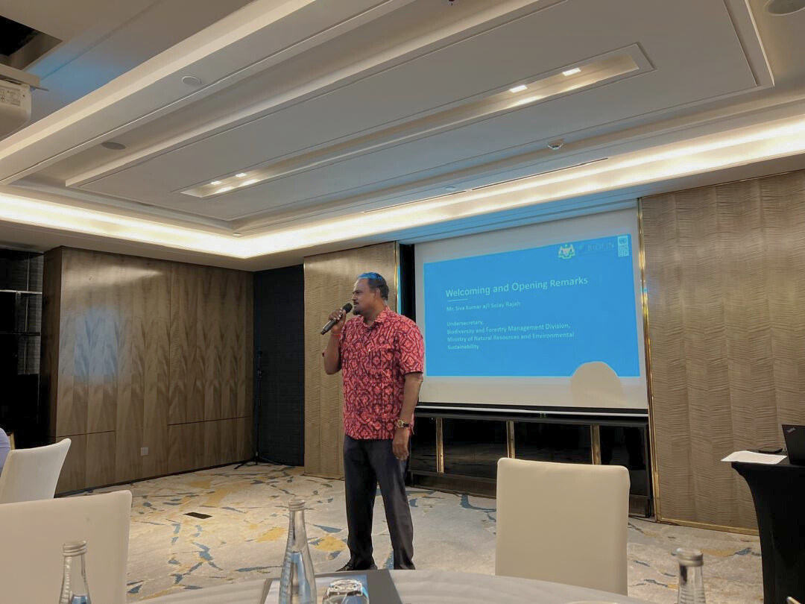
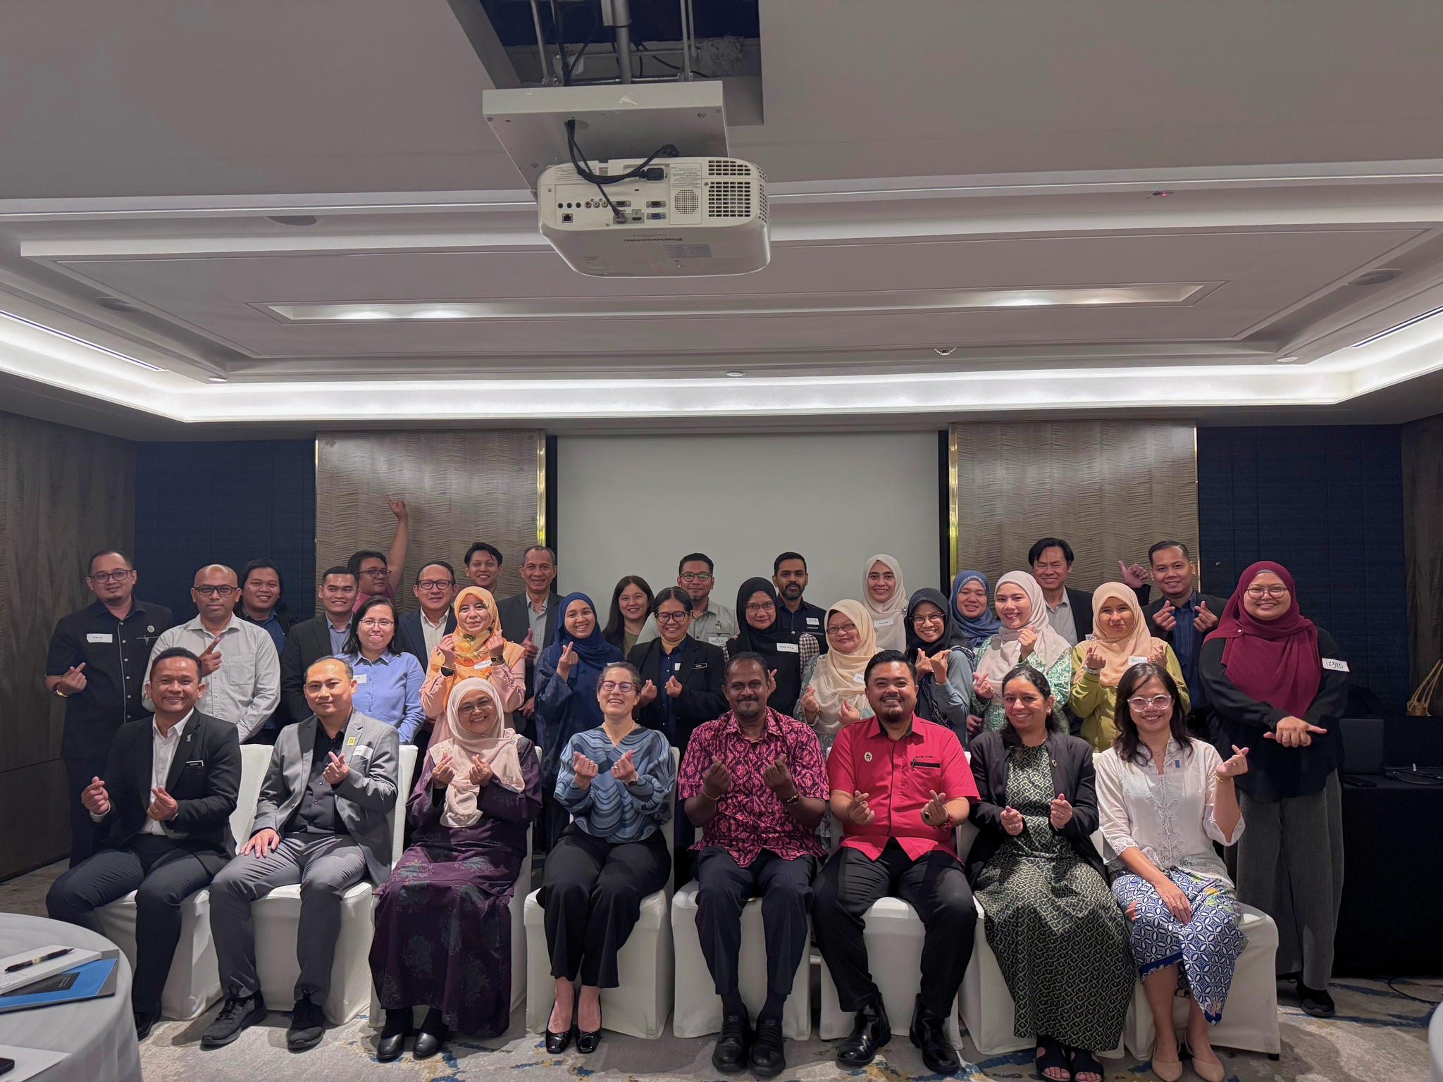
EFT Validation and Way Forward Workshop on 19–20 May 2025. Participants validated key findings from the 2024 Sensemaking Workshop and outlined strategic priorities to improve implementation, reporting, and measurement. The workshop also introduced ideas to enhanced private nature finance, results-based budgeting, and strengthened federal-state partnerships.
To consolidate next steps, a strategic follow-up meeting was held with NRES on 16 June 2025, which resulted in key commitments to advance the next phase of EFT implementation. These included: (i) sharing state-level EFT data with UNDP to support a national gap analysis; (ii) issuing an official circular to State Governments to facilitate a nationwide survey; (iii) identifying and supporting pilot implementation in Sarawak and Pahang; and (iv) co-convening stakeholder consultations to validate key BIOFIN outputs - including the BER, FNA, BFP, and subsidy repurposing study. These outcomes signal strengthened federal–state collaboration and reflect NRES’s leadership in advancing evidence-based, results-driven biodiversity finance.
A strategic follow-up meeting was held with NRES on 16 June 2025, which resulted in key commitments to advance the next phase of EFT implementation. These included: (i) sharing state-level EFT data with UNDP to support a national gap analysis; (ii) issuing an official circular to State Governments to facilitate a nationwide survey; (iii) identifying and supporting pilot implementation in Sarawak and Pahang; and (iv) co-convening stakeholder consultations to validate key BIOFIN outputs - including the BER, FNA, BFP, and subsidy repurposing study. These outcomes signal strengthened federal–state collaboration and reflect NRES’s leadership in advancing evidence-based, results-driven biodiversity finance.
Following the meeting, BIOFIN Malaysia completed a nationwide EFT implementation survey in collaboration with NRES and the Ministry of Economy. The survey covered all 13 states and assessed the current application, governance, and fiscal impact of EFT allocations. Preliminary findings indicate varying levels of integration and tracking mechanisms across states, highlighting opportunities for capacity-building and harmonized reporting frameworks. The data collected will serve as the foundation for the development of EFT Guidelines, which seeks to enhance effectiveness of EFT implementation aligned with Malaysia’s commitments under the National Policy on Biological Diversity (NPBD) 2022–2030 and the Global Biodiversity Framework (GBF).
With the support of the BIOFIN Global Team, the Country Office (CO) and government partners have actively participated in key global and regional conferences, positioning Malaysia as a leading voice in biodiversity finance innovation.
- BIOFIN Global Conference, Chile, 6-8th May 2025
High level representative from NRES has recommended for the BIOFIN Steering Committee to be formalised as a technical working group under the National Biodiversity Council, ensuring closer alignment between biodiversity finance efforts and national governance structures. At the time of reporting, the national BIOFIN team is working with the Ministry to establish the National Biodiversity Finance Working Group. This momentum represents a significant step forward in positioning EFT as a sustainable, results-driven mechanism for biodiversity conservation in Malaysia.
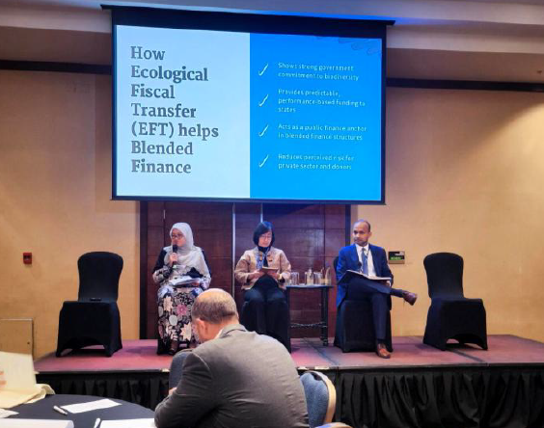
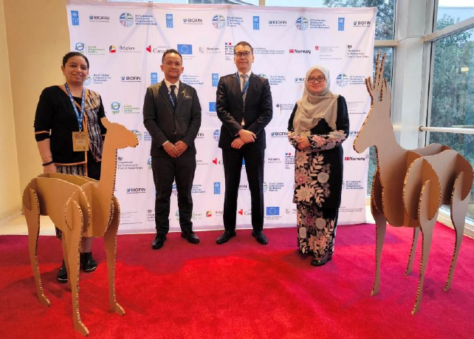
Malaysian delegation at BIOFIN Global Conference (left). Deputy Secretary speaking at the panel session on Opportunities to use EFT to steer blended financing (right).

- 11th BIOFIN Europe, Asia and the Pacific (EAPAC) Regional Dialogue, Da Nang, Vietnam, 23–25 September 2025
The Dialogue gathered representatives from over 40 countries across the region and served as an important platform to share experiences, lessons, and innovations on biodiversity finance. It also reinforced Malaysia’s growing leadership in the region through the sharing of our finance solutions and institutional approaches under BIOFIN Malaysia.
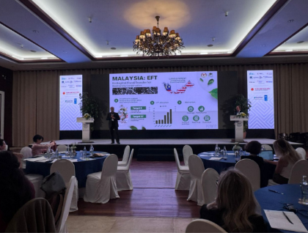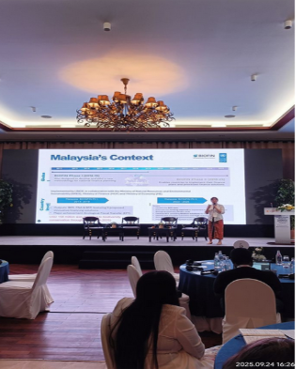
Mr. Dzulkarnain from NRES led a country session presenting Malaysia’s Ecological Fiscal Transfer (EFT) as a key biodiversity finance solution, highlighting how the mechanism has successfully linked fiscal policy with conservation outcomes (left) CO participated as panelist in the technical session on “Aligning Policies and Institutions to Mobilize Biodiversity Finance” (right)

Imposition of the Ecosystem Conservation Fee in the State of Sabah in Malaysia
This Finance Solution (FS) aims to create an enabling legal environment to impose the PES-like Ecosystem Conservation Programme (ECP) as a sustainable mechanism for the conservation, management, protection and rehabilitation of the ecosystems, the environment, and natural resources in Sabah. It is expected that through the FS, legal frameworks, and guidelines on the ECP will be developed, approved, and imposed in Sabah. The key stakeholder for this FS is the Natural Resources Office (NRO) in the Chief Minister’s Department, Sabah. Other stakeholders are the Sabah state government’s ministries and agencies including the State Attorney-General’s Chambers, Ministry of Finance, State Economic Planning Unit, Ministry of Tourism, Culture and Environment, Sabah Forestry Department, Sabah Parks, and Lands and Surveys Department.
The inception workshop convened on 11 July 2023 involving relevant ministries and agencies from federal and state governments and NGOs discussed on the challenges and gaps, BIOFIN-supported activities, indicators and targets. Overall, feedback from the stakeholders mainly concerns the mechanism of collection of the Ecosystem Conservation Fee (ECF), which is the primary source of funds for the ECP.
In the post-pandemic era, Sabah state is seeing 56.1% increase in visitor arrivals to Sabah in 2023 (up to October) compared to 2022, generating RM4.42 billion (USD0.95 billion) tourism receipts. The state government is committed towards implementing various initiatives and inclusive tourism programmes to ramp up the recovery momentum of Sabah’s tourism industry in the following years.
A draft enactment to impose the Ecosystem Conservation Fee (ECF) for the Sabah Government developed by the UNDP-GEF Biodiversity Conservation in Multiple-Use Forest Landscapes in Sabah, Malaysia project back in January 2020 remains a draft at the State Attorney-General’s Chambers. Although innovative sustainable financing remains of interest to the state, there is no government agency taking the initiative to expedite the imposition of the ECF at present.
In June 2024, BIOFIN Team had a high-level dialogue with the Sabah Government to regain the momentum for the imposition of ECF. As an outcome of the dialogue, a cabinet paper was drafted and presented to the new state cabinet, which has changed since 2020. The cabinet paper on the ECF Enactment was tabled in the State Cabinet for approval on 2nd October 2024, the Sabah Cabinet decided to postpone the decision for ECF implementation in Sabah until after the State election scheduled in 2025.
In the first half of 2025, UNDP-BIOFIN Malaysia revitalised efforts to operationalise the Ecosystem Conservation Fee (ECF) in Sabah as a sustainable, locally anchored financing solution for biodiversity. In partnership with the Sabah Forestry Department, a high-level Workshop on Revisiting the Ecosystem Conservation Fee was held on 18 June 2025 in Kota Kinabalu, bringing together 37 participants from state ministries, agencies and local authorities.
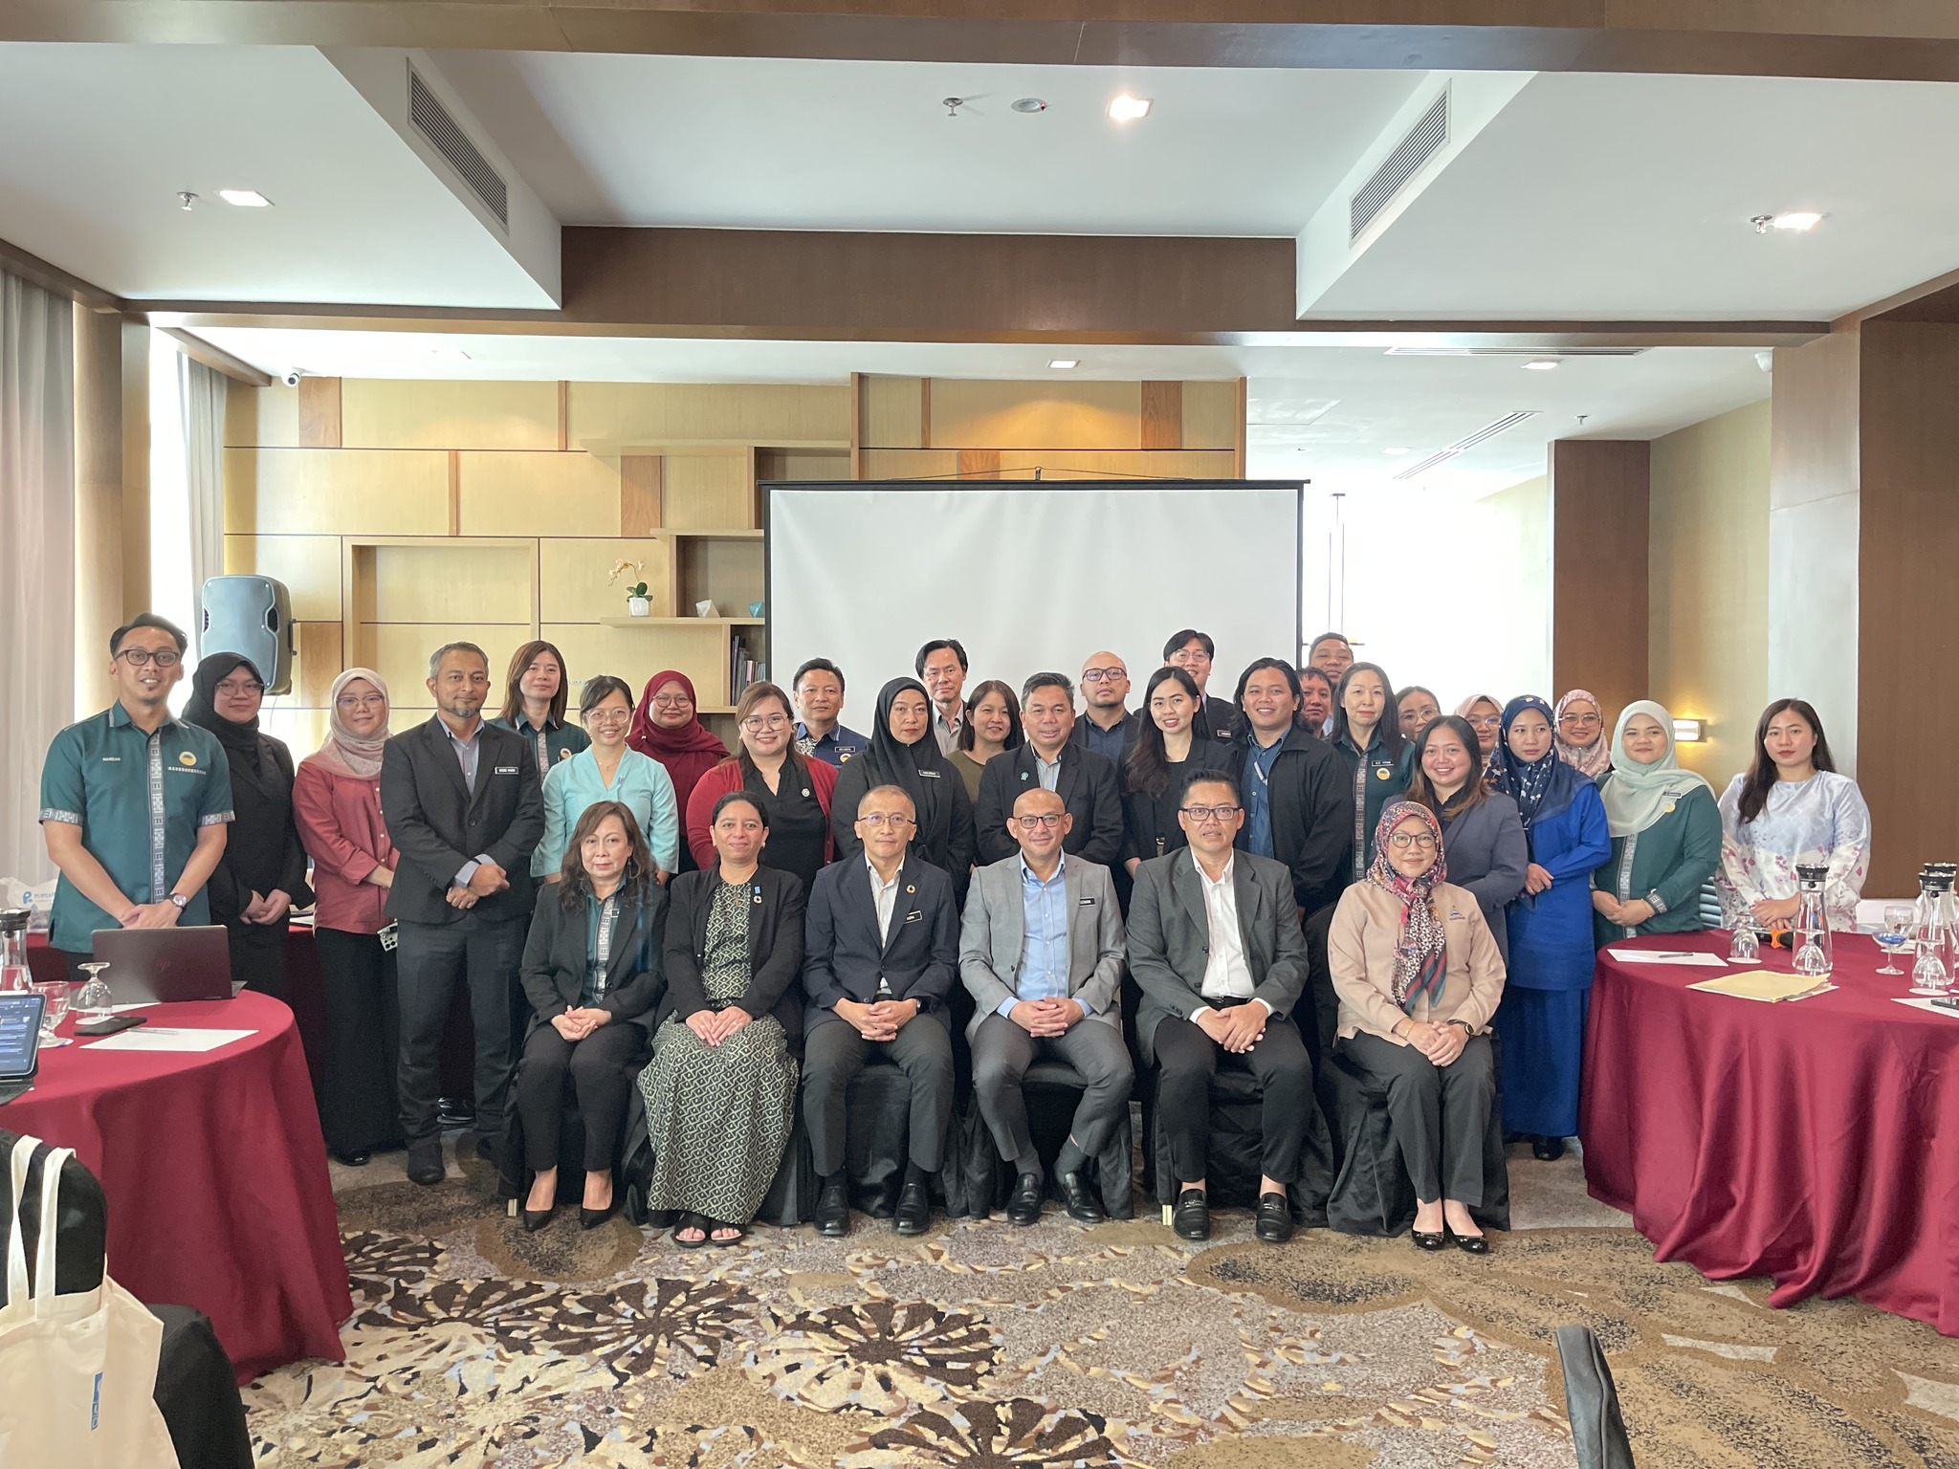
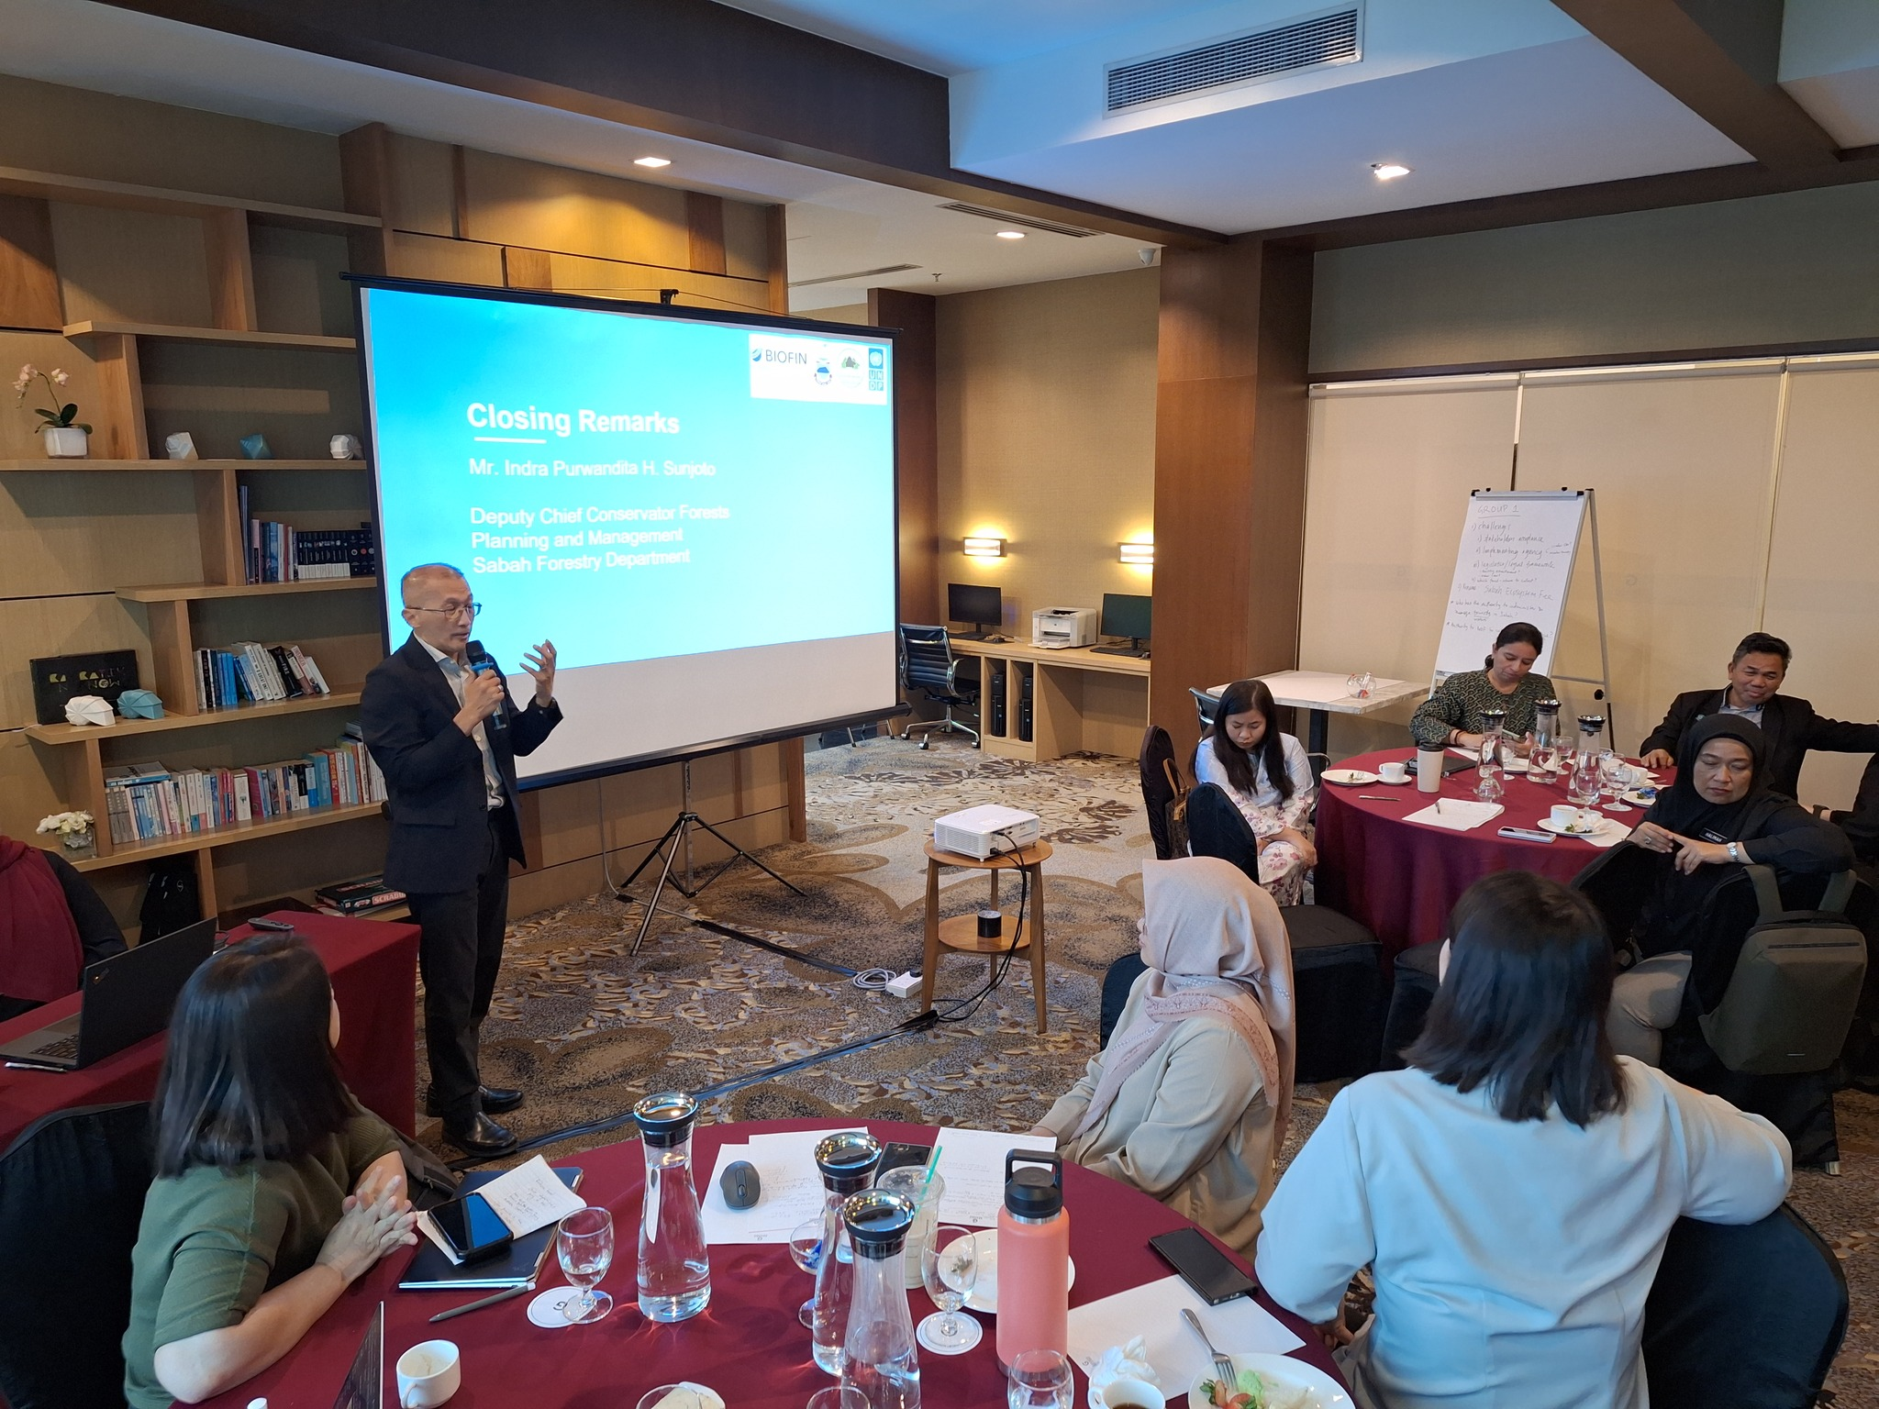
The June 2025 workshop reaffirmed the relevance of the ECF as a biodiversity finance instrument, especially in the context of Sabah’s post-pandemic tourism recovery. Participants recognized its potential to generate RM19.9–29.6 million annually by levying a nominal fee on departing non-resident tourists. However, critical implementation challenges remain, including institutional fragmentation, legislative uncertainty, overlap with existing park fees, tourism taxes, and limited stakeholder awareness.

On 18 June 2025, UNDP Malaysia and the Sabah Forestry Department co-hosted a workshop in Kota Kinabalu to reignite momentum for the Ecosystem Conservation Fee and explore sustainable biodiversity finance solutions for the state.
The workshop concluded with a renewed multi-agency commitment to finalise the enabling legal and institutional framework, with follow-up consultations planned to involve the Ministry of Finance Sabah, Ministry of Tourism, Culture and Environment (MTCE), Sabah Biodiversity Centre, and other important stakeholders. Participants also proposed leveraging Ecological Fiscal Transfer (EFT) allocations to support ECF-related engagement and outreach activities. This reactivation of the ECF process signals strong subnational momentum toward diversifying and institutionalizing nature-positive revenue streams in Malaysia.
Following the High Level discussions 22nd August 2025, internal technical meeting were held on 28th October and 20th November 2025 between the Ministry of Finance Sabah, the Attorney General’s Chambers, SFD and related partners to formalize the legal instrument that will institutionalize the ECF under state legislation.
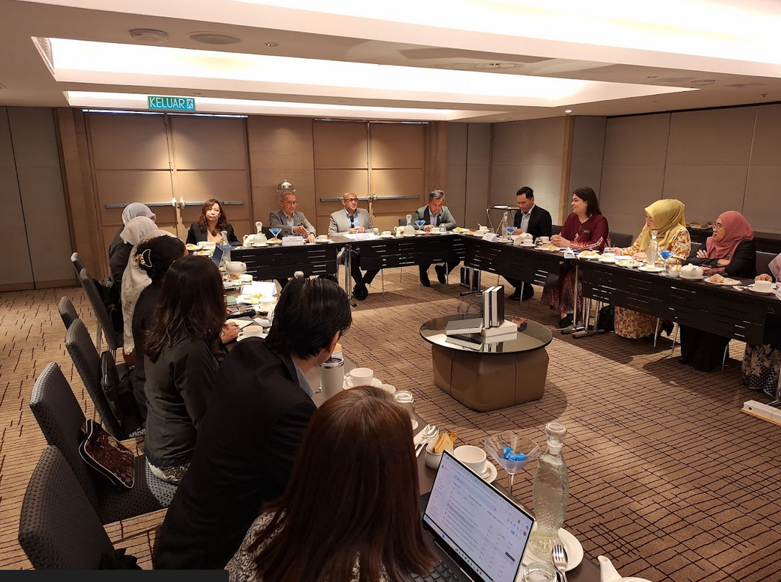
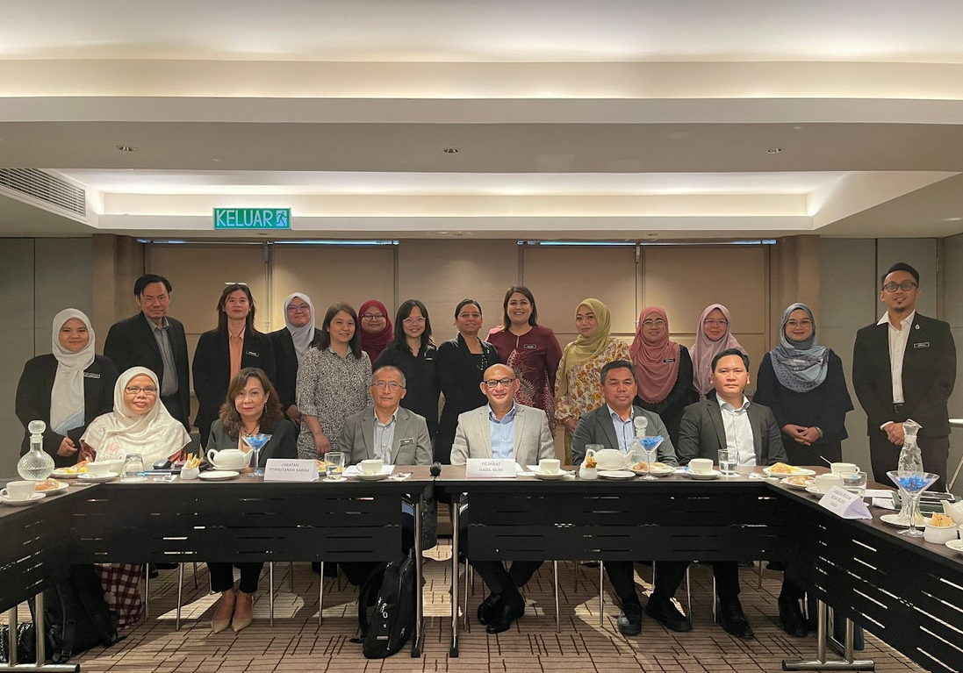
Highlevel technical discussion 22nd August 2025 “High-Level Closed-Door Meeting on Advancing the Ecosystem Conservation Fee Initiative” in Kota Kinabalu. The meeting was co-organised by UNDP Malaysia and the Sabah Forestry Department (SFD) and convened high-level key state agencies to discuss and agree on the lead implementation agency, the possible legal instrument to implement ECF and steps forward. The meeting was chaired by the Secretary of Natural Resources Office (NRO) and participated by senior representatives.

Enabling and Scaling up Nature-related Financial Disclosures
In June 2024, UNDP Malaysia has also conducted a consultation and training workshop with 28 FIs, regulators and associations on “Net-Zero & Nature Positive: Introductory Training on Biodiversity and Climate Change for Financial Institutions” in partnership with the Joint Committee on Climate Change (JC3) - a regulator-industry platform, aiming to pursue collaborative actions for building climate resilience within the Malaysia financial sector. Based on the feedbacks from FIs, regulators and corporates during the training, the following challenges emerged: (1) the lack of capacity for financial institutions and businesses to measure and report their impact on biodiversity; (2) the lack of a platform for data related to biodiversity-sensitive areas (ENCORE being a good start, but national data still lacking); (3) confusion on the multiple reporting standards and frameworks. The initial engagements through the workshop opened the doors for future engagement on the topic with the FIs, Securities Commission, Stock Exchange (Bursa Malaysia) and Malaysian FIs, including CIMB, Maybank, Hong Leong Assurance.
In COP 28, BNM announced initiatives to develop a risk assessment guide for Malaysian financial institutions and businesses, with the World Bank (WB) and in consultation with Taskforce on Nature-related Financial Disclosures (TNFD). In August 2024, UNDP-BIOFIN Malaysia has been approached by BNM to provide additional support to this process. The guide will take the form of a case study on the application of the TNFD Locate, Evaluate, Assess and Prepare (LEAP) approach on significant value chain(s) for Malaysia. The case study will serve as practical guidance and surface insights on implementation challenges and considerations alongside providing appropriate policy suggestions to ease implementation. This is to assist financial institutions (and their clients) in integrating nature-related considerations into their credit and underwriting decisions and ultimately the adoption of TNFD recommendations. This will also provide a demonstration effect to other developing countries facing similar challenges.
In the first half of 2025, BIOFIN Malaysia continued to advance national readiness for nature-related financial disclosure through strategic engagements aligned with the Taskforce on Nature-related Financial Disclosures (TNFD). This aligns with Malaysia’s push toward sustainability-aligned capital markets, following the Securities Commission’s launch of the National Sustainability Reporting Framework (NSRF) in March 2025, which incorporates ISSB-aligned climate and nature disclosure standards.

The Biodiversity Finance Initiative - BIOFIN Malaysia and Bank Negara Malaysia participated in a 3-day workshop on the Taskforce on Nature-related Financial Disclosures (TNFD) hosted by the TNFD Secretariat and the National University of Singapore from 6 May 2025 to 8 May 2025
A milestone during this reporting period was BNM and BIOFIN Malaysia’s participation in the TNFD Train-the-Trainer (TtT) Workshop held from 6–8 May 2025 at the National University of Singapore. Organised by the TNFD Secretariat, the workshop brought together regional leaders—including delegates from Bank Negara Malaysia (BNM), Permodalan Nasional Berhad (PNB), Petronas, and WWF Malaysia—to build capacity in delivering the TNFD’s LEAP approach. BIOFIN Malaysia’s involvement has directly enhanced its ability to support local institutions in preparing for nature-related disclosures under the NSRF and ISSB framework. The training also highlighted contextual challenges for SMEs and emphasized the need to adapt TNFD implementation to the Malaysian regulatory environment.
Following this, Bank Negara Malaysia joined BIOFIN at the Global BIOFIN Conference in Santiago, Chile (June 2025), where Malaysia was profiled as a regional frontrunner in nature-related financial innovation. BNM’s participation underscored the growing interest of central banks in integrating nature into financial risk supervision and reaffirmed the country’s commitment to aligning monetary, fiscal, and environmental policy goals.
In parallel, the partnership with BNM has made significant progress on multiple fronts. It successfully completed an ENCORE assessment for the Malaysian PLC and FI pilots. BIOFIN–TNFD collaborated with Securities Commission and Malayia Stock Exchange (Bursa Malaysia), from this collaboration, BIOIFN has completed the Corporate Readiness Assessment on Nature-related Risk Disclosure, which surveyed over 45 public-listed companies (PLCs) and conducted 12 in-depth interviews with leading corporations across key sectors including finance, plantation, construction, and manufacturing. The findings revealed that while 80% of participating PLCs recognized the strategic importance of nature-related risks, only a small proportion had begun integrating such considerations into enterprise risk management or sustainability reporting systems. Capacity constraints, data gaps, and limited awareness of the TNFD framework were identified as primary barriers. These insights now serve as the foundation for targeted interventions and policy dialogues to mainstream nature-related risk disclosure in Malaysia’s private sector.
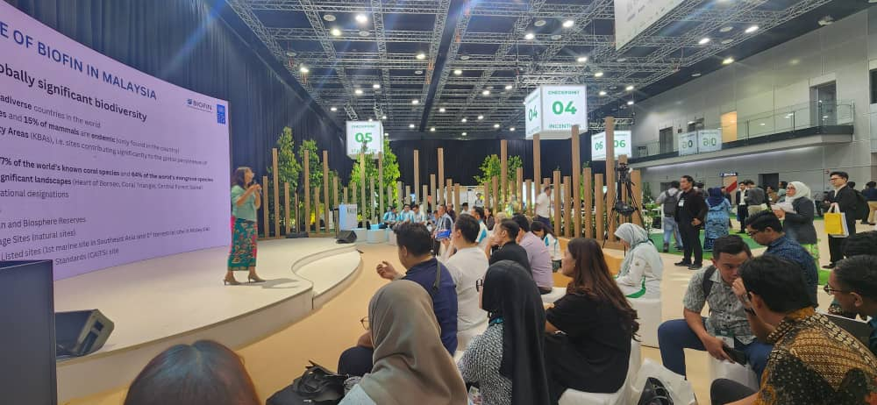
16th October 2025 International Greentech & Eco Products Exhibition and Conference Malaysia (IGEM)
BIOFIN Malaysia is working on a partnership with Malaysia Green Technology Corporation (MGTC) to initiate the development of a national TNFD LEAP Capacity Building Programme, designed to train corporate sustainability professionals and financial institutions on practical steps to apply the TNFD LEAP approach. The training modules emphasize the integration of nature-related considerations into decision-making, risk assessments, and disclosure practices. BIOFIN has highlighted the role of TNFD as a bridge between finance, biodiversity, and corporate sustainability during IGEM 2025.
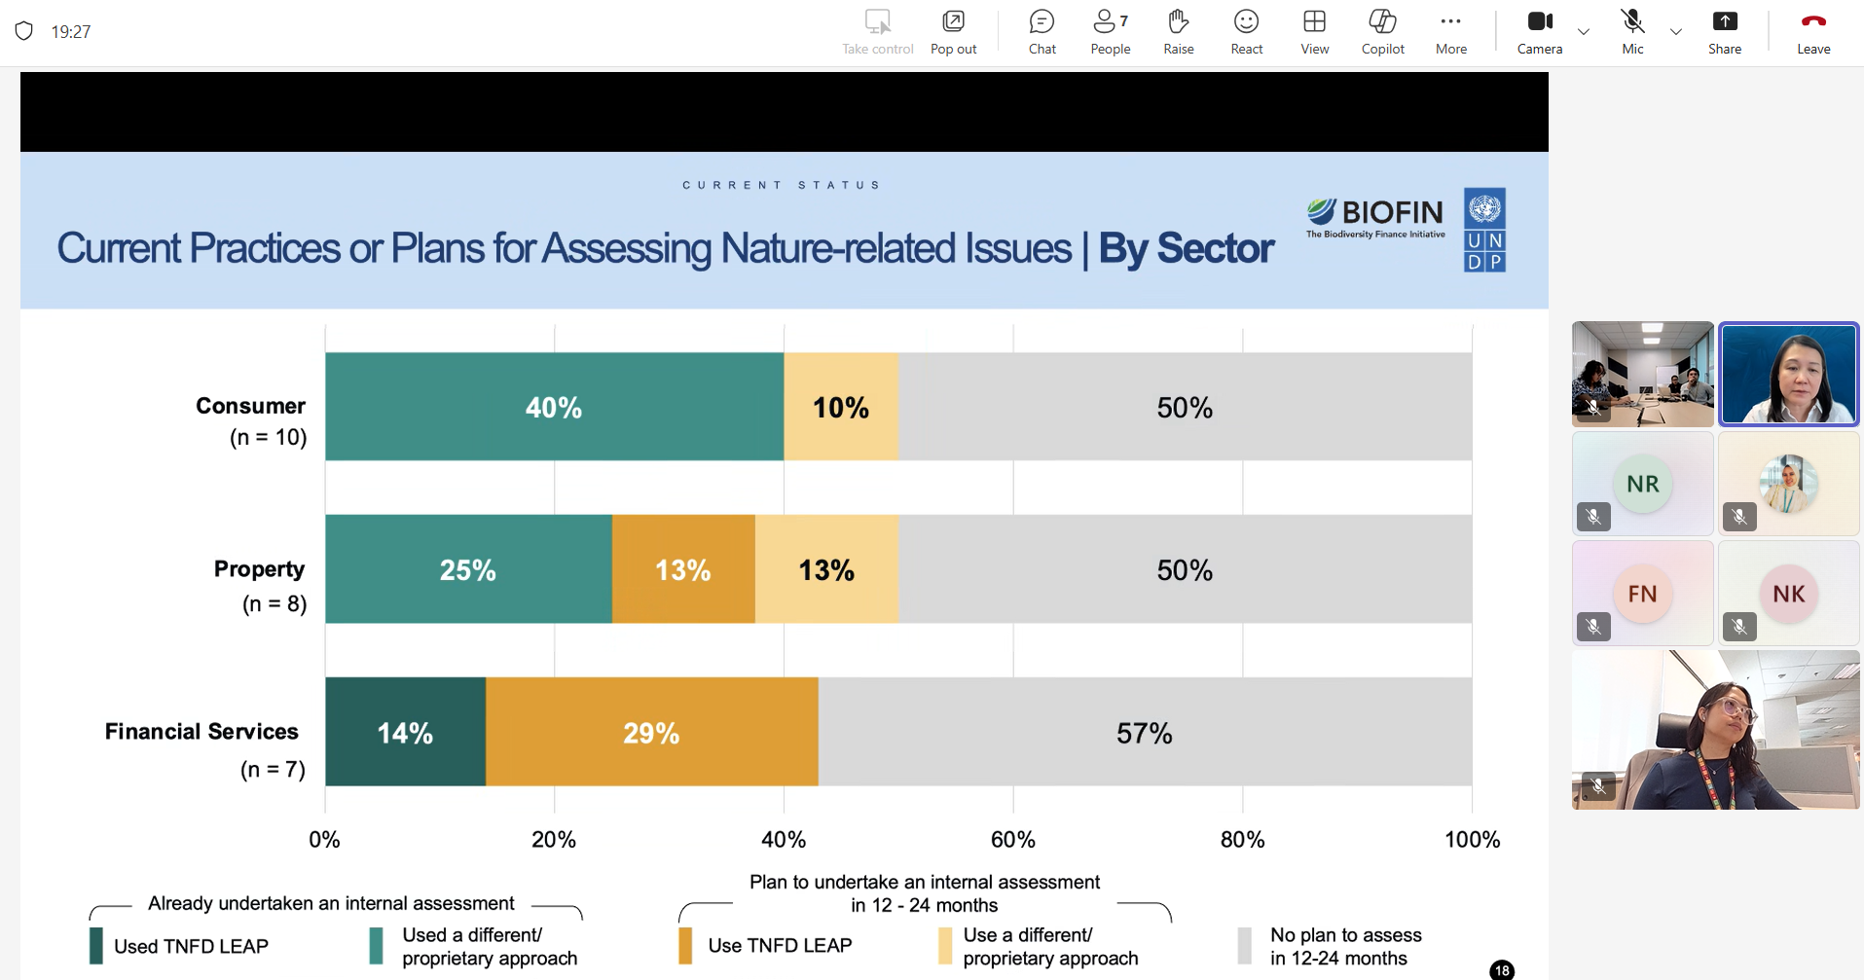
Presentation of corporate nature related risk TNFD studies to Securities Commission 1st December 2025

Update of BIOFIN Methodology Studies (PIR, BER, FNA)
In 2025, BIOFIN Malaysia updated the BIOFIN methodological framework - the Policy and Institutional Review (PIR), Biodiversity Expenditure Review (BER), Finance Needs Assessment (FNA), and Biodiversity Finance Plan (BFP) - to strengthen the strategic, evidence-based foundations for national biodiversity finance reform. These studies form the analytical backbone for identifying policy gaps, understanding financing trends, quantifying needs, and designing actionable finance solutions under Malaysia’s biodiversity and climate commitments.
Significant progress was made to strengthen the national validation and institutional uptake of the BIOFIN methodology. A technical meeting held with NRES on 15 June 2025 reaffirmed the Ministry’s commitment to advancing the Policy and Institutional Review (PIR), Biodiversity Expenditure Review (BER), Finance Needs Assessment (FNA), and Biodiversity Finance Plan (BFP). NRES and UNDP agreed to co-convene a dedicated multi-stakeholder validation meeting in October 2025, bringing together the Ministry of Economy (ME), Ministry of Finance (MOF) and the Department of Statistics Malaysia (DOSM). This marks an important step in ensuring the robustness, credibility, and national ownership of the BIOFIN dataset.
BIOFIN Malaysia is now revising the BER through additional desktop research and triangulation of data, with a specific emphasis on incorporating state-level financial information, including allocations referenced in State Budget Speeches and publicly available budget documents. NRES has kindly offered to assist in obtaining state financial data that is not publicly accessible, further strengthening the comprehensiveness and accuracy of the analysis. The updated BER will provide a more complete national picture of biodiversity-related public expenditure across both federal and state governments.
BIOFIN Malaysia will develop a policy brief synthesizing insights from the PIR, BER, FNA and BFP to support wider mainstreaming of the BIOFIN dataset. The brief will be used to inform key national processes, including: (i) post-Budget 2026 discussions, (ii) the preparation of Malaysia’s 7th National Report to the CBD, and (iii) Malaysia’s resource mobilisation strategy leading up to CBD COP 17. This work is expected to enhance the visibility and policy relevance of BIOFIN’s analytical products, strengthen interagency coordination, and reinforce Malaysia’s positioning as a regional leader in evidence-based biodiversity finance planning.

Social inclusion stories
The Finance Solutions (FS) in Malaysia under the BIOFIN Phase II Extended are intervening on the policy and administration level. Hence, the direct beneficiaries are the civil servants and policy makers at the federal, state and local levels. Emphasis on gender balance will be given at all levels of decision-making, as well as on training and capacity development with equitable participation of women. In addition, gender equality will be promoted in the grant mechanism and award specific to the disbursement and defrayment of the Sabah Ecosystem Conservation funds as ECP grants.

Lessons learned and adaptive measures:
Amid rising global economic uncertainty, the recent re-escalation of tariff measures under the Trump administration—particularly those affecting Malaysia’s key export sectors - may compel the Government of Malaysia to divert fiscal resources toward cushioning impacted industries. This shifting macroeconomic landscape could deprioritise biodiversity-related investments, including nature-positive fiscal instruments such as the Ecological Fiscal Transfer (EFT), and limit bandwidth for advancing corporate green transition policies and nature-related risk disclosures, including adoption of the TNFD framework.
The unexpected resignation of YB Nik Nazmi, former Minister of Natural Resources and Environmental Sustainability and a key champion of biodiversity finance, has introduced further uncertainty regarding the continuity of high-level political support, particularly for mechanisms like EFT that rely on sustained federal commitment.
Despite these risks, recent high-level engagements with both the Ministry of Natural Resources and Environmental Sustainability (NRES) and the Ministry of Finance (MoF) indicate growing recognition of EFT as a strategic and long-term mechanism to incentivise and compensate states for opportunity costs associated with forest conservation. Both ministries acknowledged EFT’s role in easing federal–state fiscal tensions and expressed openness to institutionalising the mechanism beyond its current discretionary form. Encouraged by this renewed momentum, BIOFIN Malaysia will resume work on identifying possible pathways to institutionalise EFT, integrating new policy perspectives and fiscal reform opportunities. Efforts will continue to maintain policy coherence and advocate for integrating biodiversity into Malaysia’s broader economic and fiscal planning agenda, ensuring continued progress despite emerging political and economic headwinds.
In 2025, Malaysia’s leadership in innovative biodiversity finance gained international visibility through the selection of the BIOFIN Ecological Fiscal Transfer (EFT) Finance Solution as one of the Top 20 global biodiversity finance solutions to be showcased on the PANORAMA – Solutions for a Healthy Planet global platform. The publication, developed jointly by BIOFIN Malaysia and NRES, highlights Malaysia’s pioneering efforts in integrating ecological indicators into federal–state fiscal transfers and demonstrates the measurable conservation outcomes achieved since EFT’s introduction. The recognition places Malaysia among a curated group of global frontrunners demonstrating scalable, evidence-based approaches to closing the biodiversity financing gap.

Risks

Programmatic risks (risks to the programme)
Five FS-specific risks have been identified and assessed as being of ‘Moderate’ significance. The details are described in the following table.
Table 1: Risk register for BIOFIN Malaysia
# | Event | Cause | Impact(s) | Risk Category and Sub-category (including Risk Appetite) | Impact, Likelihood & Risk Level  (see Annex 3 Risk Matrix) | Risk Valid From/To | Risk Owner  (individual accountable for managing the risk) | Risk Treatment and Treatment Owner
1 | There is a risk that the EFT allocation as an additional incentive for the states will be halted by the federal government | As a result of change of government or change of government priorities subject to political and financial conditions as there is no legal framework that govern EFT scheme at present | Which will impact in the quantum of initiatives for biodiversity conservation and management by the state government. | 7. STRATEGIC (7.5. Government commitment) - UNDP Risk Appetite: OPEN TO SEEKING | Likelihood:  4 - Highly likely  Impact:  2 - Minor  Risk level:  MODERATE (equates to a risk appetite of EXPLORATORY) | From: 01-Jul-23  To: 31-Dec-25 | Yi Wei, YAN | Risk Treatment 1.1: The Finance Solution (with enablers present) will establish policy and legal framework in effort to entrench EFT scheme in the Federal Constitution.  Risk Treatment Owner: NRES
2 | There is a risk that the Finance Solution on EFT receives lack of buy-in of state governments specifically the State Treasury and State Economic Planning Unit | As a result of lack of understanding and capacity in managing the EFT allocation from the Federal government | Which will impact in effectiveness of EFT utilization for biodiversity conservation purposes in the states. | 3. OPERATIONAL (3.5. Partners’ engagement) - UNDP Risk Appetite: EXPLORATORY TO OPEN | Likelihood:  2 - Low likelihood  Impact:  3 - Intermediate  Risk level:  MODERATE (equates to a risk appetite of EXPLORATORY) | From: 01-Jul-23  To: 31-Dec-25 | Yi Wei, YAN | Risk Treatment 2.1: The Finance Solution activities will include a range of mechanisms to generate state agencies' awareness on ecological criteria and the EFT utilisation through sensitisation and engagements with state governments to be directly involved in the development/revision of the ecological fiscal criteria and decision-making process.  Risk Treatment Owner: NRES
3 | There is a risk that the state government is resistant to abide by the ecological fiscal criteria developed | As a result of the state government not seeing the value in abiding with the approaches promotes | Which will impact in implementation effectiveness of the EFT scheme for biodiversity conservation. | 7. STRATEGIC (7.5. Government commitment) - UNDP Risk Appetite: OPEN TO SEEKING | Likelihood:  3 - Moderately likely  Impact:  3 - Intermediate  Risk level:  MODERATE (equates to a risk appetite of EXPLORATORY) | From: 01-Jul-23  To: 31-Dec-25 | Yi Wei, YAN | Risk Treatment 3.1: Engagement of state government agencies during the development/revision of the EFT implementation guideline.  Risk Treatment Owner: NRES
Risk Treatment 3.2: Capacity building of state government agencies throughout the Finance Solution implementation with a cohort of sustainability champions from across governmental sectors to ensure the durability of the results achieved on the FS.
Risk Treatment Owner: NRES
4 | There is a risk that the finance solution on the imposition of Ecosystem Conservation Fee Enactment in Sabah is put on hold or delay | As a result of the change of government and government priorities subject to political condition. | Which will impact in the effort to create an enabling legal environment to impose PES-like programme as a sustainable mechanism for the conservation and management of biodiversity and natural resources in Sabah. | 7. STRATEGIC (7.5. Government commitment) - UNDP Risk Appetite: OPEN TO SEEKING | Likelihood:  3 - Moderately likely  Impact:  3 - Intermediate  Risk level:  MODERATE (equates to a risk appetite of EXPLORATORY) | From: 01-Jul-23  To: 31-Dec-25 | Yi Wei, YAN | Risk Treatment 4.1: The Finance Solution activities will be implemented in close collaboration with all the stakeholders for the institutionalization of the sustainable financing mechanisms for biodiversity conservation in Sabah.  Risk Treatment Owner: Sabah Government
5 | There is a risk that the imposition of the Ecosystem Conservation Fee in Sabah creates grievance or objection form potentially affected group, in this case the visitors to Sabah | As a result of the imposition to collect the regulated fees | Which will impact in the reputational of Sabah. | 5. REPUTATIONAL (5.1. Public opinion and media) - UNDP Risk Appetite: CAUTIOUS | Likelihood:  3 - Moderately likely  Impact:  3 - Intermediate  Risk level:  MODERATE (equates to a risk appetite of EXPLORATORY) | From: 01-Jul-23  To: 31-Dec-25 | Yi Wei, YAN | Risk Treatment 5.1: Relevant guidelines including on the social and environmental safeguards, and grievance mechanism are developed and made known to public.  Risk Treatment Owner: Sabah Government

Social and environmental risks (of the programme)
The BIOFIN country programme does not generate additional social and environmental risks. Indeed, the programme works to mitigate existing risks by integrating UNDP’s programming principles for strengthening social and environmental sustainability (SESP), and the programme is directly aligned with Standard 1 of the project-level standards therein, viz., Biodiversity Conservation and Sustainable Natural Resource Management.

List of annexes and related notes
The following annexes are included in this report:

Annex 1: Indicator Tracking Table (in Excel)
The Indicator Tracking Table provides an up-to-date snapshot (subject to the availability of related data) of progress made towards the BIOFIN country programme’s M&E indicator targets.

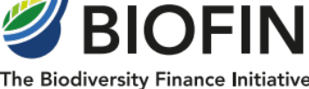

World Bank and Bank Negara Malaysia (BNM) (2022). An Exploration of Nature-Related Financial Risks in Malaysia. Kuala Lumpur. World Bank.
Brander, L., Yeo, B. H, Nurliyana, A., Gan, P. C. and Tan, A. S. L. (2023). Economic Values, Costs and Benefits of Terrestrial Protected Areas in Peninsular Malaysia. A report produced and supported under the Enhancing the Effectiveness and Financial Sustainability of Protected Areas in Malaysia – a project supported by UNDP with Global Environment Facility (GEF) grant financing and implemented by the Department of Wildlife and National Parks.

